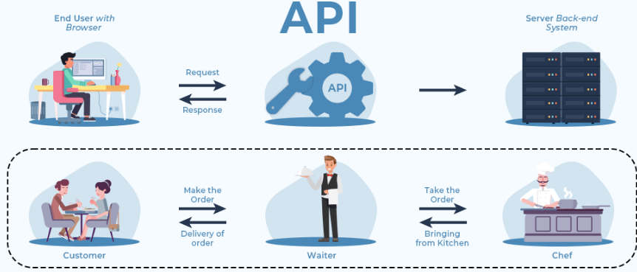
Application Programming Interface which is a collection of communication protocols and subroutines used by various programs to communicate between them
To provide additional security layers to the data, HTTP headers, query string parameters, or cookies are used.
If we talk about the architectures, API’s architectures are:
- REST (Representational State Transfer)
- SOAP (Simple Object Access Protocol)

Both define a standard communication protocol for the exchange of messages in XML (Extensible Markup Language).

What are REST APIs?
REST stands for Representational State Transfer, and follows the constraints of REST architecture allowing interaction with RESTful web services. It defines a set of functions (GET, PUT, POST, DELETE) that clients use to access server data
Its main feature is that REST API is statelessness, i.e., the servers do not save clients’ data between requests.

What is a Web API?
Web API Is simply an API for the web. It is an API that can be accessed using the HTTP protocol. It can be built using Java, .nET, etc.

PROGRAM APIs
It makes a remote program appear to be local by making use of RPCs (Remote Procedural Calls). SOAP is a well-known example of this type of API.
- SOAP (SIMPLE OBJECT ACCESS PROTOCOL): It defines messages in XML format used by web applications to communicate with each other.

What is API Integration?
API Integration is the connection between two or more applications, via APIs, letting you exchange data.

What is API Testing?
API Testing is a kind of software testing that analyzes an API in terms of its functionality, security, performance, and reliability.

API Testing Tools:
- Postman
- Soap UI

